Health Impact of Climate Change – Preparing Your Communities and Practices

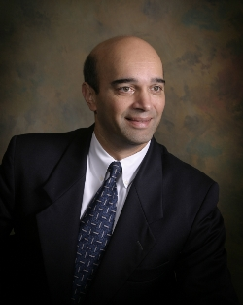
“Climate Change and Health: The Greatest Health Threat & Opportunity of the 21st Century”
- The principles and indicators of Climate Change
- The Health Effects:
- Heat waves
- Respiratory effects:
- Vector borne and Waterborne diseases
- Food security
- Mental/emotional effect
- Mass migration
- Opportunities at the international/national and individual level for mitigation of health effects.

Nitin S. Damle, MD, MS, MACP is the past president of the American College of Physicians and Associate Clinical Professor of Medicine at the Alpert Medical School of Brown University. He is the founding partner of an eight-internist practice in Rhode Island. He is also past president of the Rhode Island Medical Society. Dr. Damle is a graduate of the University of Michigan with post graduate training at the Brown University affiliated hospitals. Dr. Damle’s areas of expertise include the health effects of climate change and has lectured all over the United States and the world over the past three years.

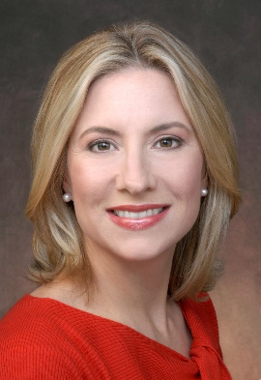
“Healthcare Delivery and the Climate Crisis”
- Describe environmental footprint and current sustainability practices of US Healthcare delivery system
- Explain impact of healthcare footprint on patient population and community health outcomes
- Detail solutions and strategies to reduce the negative environmental impacts of providing care

Emily Senay, MD, MPH is an Assistant Professor of Medicine in the Department of Environmental Medicine and Public Health at the Icahn School of Medicine at Mount Sinai (ISMMS) in New York City. She is a clinician at the World Trade Center Health Program, Center of Clinical Excellence. She is former Chair of Sustain Mount Sinai, the executive sustainability committee for Mount Sinai Health System and founder of Clinical Climate Change, an annual academic conference for allied health through the Institute for Exposomic Research at ISMMS. She studies the impact of healthcare delivery on the climate crisis and opportunities for health systems as business entities to reduce their environmental footprints and operational costs. She is teacher and mentor in the medical and graduate schools with specific expertise in the drivers and health impacts of the climate crisis and sustainability practices. Dr. Senay was a broadcast news health and medical correspondent for more than 20 years with CBS News and PBS News. She is a frequently invited speaker and moderator for medical, scientific and lay audiences. She received her MD and MPH from ISMMS in New York City, and her BA from the University of Chicago. She is board certified in General Preventive Medicine.

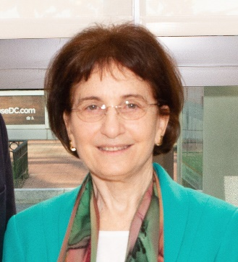
“What Physicians Can Do About Climate Change”
- Describe what is known regarding physicians’ thoughts about climate change
- List the attitudes of Americans on climate change (the “Six Americas”)
- Describe how physicians as trusted communicators can inform the public in their roles as a doctor, influencer, and member of the medical community.

Mona Sarfaty, MD MPH FAAFP, is the founding Director of the Medical Society Consortium on Climate and Health based within the George Mason University Center for Climate Change Communication. She is a family medicine physician and public health doctor who has engaged in teaching, research, and advocacy for over 30 years. As an academic faculty member with expertise in primary care, preventive services, and health policy, she lectured at national & regional venues including medical societies, health plans, health departments, professional organizations, & government conferences. In the middle of her career she worked as a Senior Health Policy Advisor for the U.S. Senate Health Committee for 7 years where she planned hearings, wrote legislation, negotiated policy, and met with constituents. She is the author of widely circulated guides and publications, peer reviewed articles and book chapters. She founded the Consortium in 2016 after several years of collaboration with medical societies to assess physician experience with the health effects of climate change, and their attitudes and interest in engaging on the problem. She has received awards for innovation from the Maryland Hospital Association, the Primary Care Coalition of Montgomery County, Maryland, and the American Public Health Association Medical Care Section. She received her MD from the State University of New York at Stony Brook, her MPH from George Washington University, and her BA from Harvard University.

